Surf's up in Minnesota, wipeout ahead
Wakesurf boats are disrupting shores, lake bottoms and other boaters.
By Ron Way

JULY 19, 2021 — 5:45PM
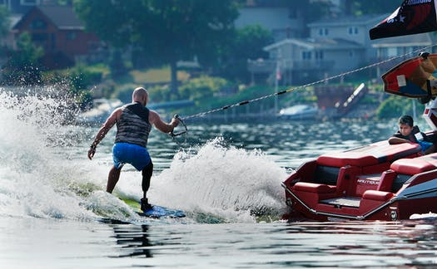
DAVID JOLES, STAR TRIBUNE
The 2021 Minnesota Wakesurf Championship on Lake Minnetonka kicked off July 16 with two wake surfing group events.
TEXT SIZE

22

EMAIL

PRINT
MORE
Another invasive species is showing up on recreational lakes, one that could become more insidious than zebra mussels or curly pondweed. They're brightly colored, ear-pounding loud and more powerful than most cars. Unlike pondweed, these things affect lake bottoms, lake surfaces and lakeshores.
They're wakesurf boats, the hottest-selling watercraft in Minnesota and Wisconsin. The pricey rigs are specially built to create 2-foot waves, cresting ever higher with newer versions.
Starting a few years back, boats were fitted with ballast tanks to push their sterns down and churn big waves for steeper launch for wakeboarders to fly and twist and flip.
But like most things in a bigger-is-better culture, the little-noticed wake boats started growing ever longer with larger ballast tanks sucking in a ton or more of water with ever-larger engines and boombox speakers sending mega decibels of rockin' tunes bouncing across water, invading entire shore-land neighborhoods, like it or not.
Waves soon became so big that mostly young hotshots could surf without a tow rope. Wake boats became wakesurf boats. Underneath, adjustable stabilizing flaps can better build and shape waves to, among other things, sync to the skill of the boarder and even to suit left- or right-footed surfers.
Next up are surf pontoons with plush seating atop 25-foot platforms that carry up to 20 partiers who sometimes gather strategically on deck to build still bigger waves to complement those created by ballast tanks now holding two-plus tons of water. Engines up to 450-horsepower propel the whole shebang. It could be yours for $150,000 to $200,000-plus, with each fill of marina gas topping $300.
But waves of another sort are rising ("Wake boats churn up controversy on lakes," front page, July 19) — fast-growing concern and ripples of rage over what happens as wakesurfers pass and their residual: huge waves whose spreading path leave fishing boats, runabouts, pontoons and kayaks rocking, often wildly. Near shore, the waves rile bottom sediments and re-suspend harmful nutrients, especially phosphorus, that promote unwanted algae growth.
Deafening music, often replete with crude lyrics, pound the shore.As the boats move from lake to lake, leftover ballast transports invasives like zebra-mussel larvae.
Even the marine industry concedes problems and is urging boaters to voluntarily do what they can to responsibly manage their wakes and turn down the music.But anyone familiar with self-regulation knows its abject futility, and in this case there's little doubt that regulations are needed.
Wakesurf boats are coming on fast.Nisswa Marine sold some 100 wake boats this year and expects annual numbers will rise; other prominent marine outlets see similar results.
A selling point is versatility.The boats do leisurely cruises, tow tubers or skiers or wakeboarders and, of course, build bulging waves for untethered surfers.And convenience: push a button for a desired wave and a computer-generated screen display explains how to build it; another prompt gets weather detail, GPS location, water depth … or fires up seat and towel heaters.
Waterland is a toyland of competing uses.In summer, Minnesota's most popular lake, Minnetonka, is abuzz with so many watercraft and floating stuff that the surface can resemble a bathtub with a couple of splashing 2-year-olds.
The lake's many smaller bays are usually quieter … until the wakesurfers show up.
John Bendt says his Maxwell Bay has too many wakesurfers making numerous passes, with speakers full on.Bendt has formed Citizens for Sharing Minnetonka that aims to limit boat number and operating times on bodies less than 250 acres.
Similar organizations are showing up at other popular lakes around Brainerd, Detroit Lakes and Pokegama near Pine City.
The Department of Natural Resources is holding off on regulation until the University of Minnesota's water laboratory at St. Anthony Falls completes a scientific look at effects of wakesurfer waves on and under the water.It's unclear when data will be ready.
Two years ago the Minnesota Senate passed an industry-backed bill (the House didn't) to keep wakesurfers 200 feet from shore and other users, like fishing boats.Frankly, a 200-foot limit is laughable, as we experienced this summer on Le Homme Dieu Bay in Alexandria.Wakesurfer waves from well beyond 200 feet jolted our pontoon and flooded the deck.A University of Quebec study said waves are safely dissipated after 1,000 feet.
Lake-bottom effects are worse.Wakesurfers are inboards with underside props angling deep down when heavy ballast is added.The intense downward energy disrupts bottom sediment and re-suspends nutrients that fuel algae growth that, in die-off, consume oxygen and aggravate an already worrisome issue due to climate-induced lake warming.
How long before unwanted effects of wakesurfers are responsibly regulated?
Ron Way lives in Edina.

