Wake boats are churning controversy around Lake Minnetonka
Critics say the boats are loud, disruptive and may damage ecosystems.
By Katy Read Star Tribune

JULY 18, 2021 — 8:41PM
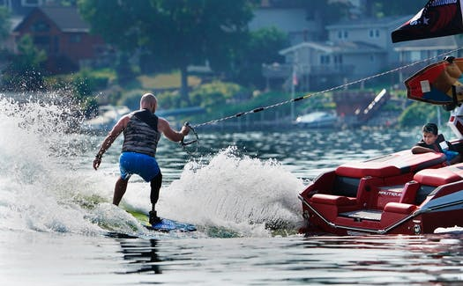
DAVID JOLES, STAR TRIBUNE
Dustin Fleming, of San Antonio, Texas, who lost a leg during combat to a bullet from a sniper, wake boarded on Lake Minnetonka while being watched by J.J. Brinson, 11, of Minneapolis with Urban Ventures on Friday, July 16 in Mound.
TEXT SIZE

286

EMAIL

PRINT
MORE
At a recent meeting of the Midwest Wakesurf Association, co-leader Andy Weigman had some good news to share: Wake boats have been less noisy this year, he'd been told — by the leader of an organization that usually complains about them.
"It looks like we're making a positive impact," Weigman told about 20 association members gathered in a backroom of the Excelsior Brewing Co.
The association has about 75 members from around Minnesota and Wisconsin and more followers on social media — wake surf newbies and pros alike, ranging from teenagers to their middle-aged parents and occasionally grandparents.
The group wants to calm the waters between people who love wake boats — watercraft designed to churn up massive wakes that surfers can ride without being tethered to the boat — and those who consider them noisy, disruptive and potentially threatening to the environment. And while they've made progress, concerns remain that could potentially result in restrictions on when and where wake boating is allowed.
Weigman and the association's co-leader, competitive wake surfer Chris Bank, have met with stakeholders on all sides of the issue — wake boat fans, wake boat foes, boat dealers, Water Patrol officers — looking for ways to ease tensions.
They've also been working to educate wake surfers to be courteous, starting with not blasting music while they're on the water.
"If it starts with respect, in my opinion, it's going to go in a good direction," Bank said.
They've made progress, said John Bendt, president of Citizens for Sharing Lake Minnetonka, a group concerned about how the boats are affecting the 14,000-acre lake.
"We have seen a notable improvement in loud music on North Arm and Maxwell bays, which I believe can be attributed to the education efforts," Bendt wrote in an e-mail to Weigman on Monday.
In an interview, Bendt said he's had up to four or five wake boats simultaneously plying the waters outside his Orono home "with their speakers blaring away. ... The windows on my house were rattling a number of times."
Weigman sympathizes. "Nobody wants to sit in their backyard and hear somebody else's music."

Boats galore
One reason the boats are stirring controversy, Weigman said, is their popularity.
"If you look out on the lake you'll see more wake surfing than ever before because it's such a family activity," he said.
Sales of wake boats, which range in price from $80,000 to more than $300,000, have been climbing for about 10 years in Minnesota and around the country, said John Wooden, owner of the Red Wing-based River Valley Power & Sport dealership.
Most dealers are sold out of 2021 stock and taking orders for 2022-model wake boats, Wooden said.
Opponents also complain that the wakes, which rise several feet above the lake surface, ripple out and interfere with other water recreation such as kayaking and paddle boarding. Last summer, a woman suffered a broken vertebra when a wake boat wave tossed her motorized boat.
"I was completely unprepared, and all I know is I just went flying; it felt like I was three feet up in the air and when I came down I was screaming with excruciating pain," said Michelle Beauchamp. She and her husband, Robert, have since sold their Wayzata summer home.
Weigman and Bank urge surfers to stay in the middle of the lake and keep their distance from other watercraft, including wake boats.
"If you show up and there's 10 boats in North Arm [Bay], that's too many," Bank said.

Environmental impact unclear
But opponents raise another concern that might be harder to solve through education: the possibility that the wakes cause environmental damage. Problems could include shoreline erosion and stirring sediment on the lake floor, uprooting aquatic plants and destroying breeding grounds for fish.
The association encourages surfers to stay in deeper water in the middle of the lake. "I tell my kids to stay the length of a football field" from shore, Bank said. Deeper water produces a better wake shape anyway, he said — in shallower places the energy bounces off the lake floor and dissipates.
University of Minnesota researchers have been studying the environmental effects of wake boats. In a letter to the Lake Minnetonka Conservation District Board, the study's leader said he expects to publish results later this year.
"We believe that our data and findings are strong enough that we also plan to publish this research in an academic peer-reviewed journal," wrote Jeff Marr of the U's St. Anthony Falls Laboratory.
The conservation district board, which sets lake regulations, is waiting to see the findings before taking any action involving wake boats.
Bendt said his group is not asking for a ban, but would like to see wake boats restricted to certain hours or areas of the lake.
"There are times of the day, especially in the morning hours, where those parts are not busy and they would be able to do their thing," he said.
Weigman and Bank oppose regulations, saying education will alleviate any need for them.
"If everybody were to do their best to adhere to these principles, the lake would become safer and a more respectful place," Weigman said.
Katy Read • 612-673-4583
Katy Read is a reporter covering Carver County and western Hennepin County. She has also covered aging, workplace issues and other topics for the Star Tribune. She was previously a reporter at the Times-Picayune in New Orleans, La., and the Duluth News-Tribune.
katy.read@startribune.com 612-673-4583

286
SHOW COMMENTS

